

Lab Mannual
Computer Networks



Instructor | Syeda Hafsa
Name | Sameer Talreja
CMS | 457795
Department | Computer Science
Semester | 3rd

Lab 1: Introduction to Network and Tools

Introduction
This lab is about Networks and tools refer to the infrastructure and software used to establish, manage, and maintain computer networks. These tools include network monitoring software, configuration management tools, performance analysis utilities, and network troubleshooting applications. They enable network administrators and engineers to monitor network health, analyze performance metrics, detect, and resolve issues, and optimize network functionality. Networks and tools play a crucial role in ensuring efficient and reliable communication, security, and scalability of modern computer networks.
Objectives
The objective of using network tools is to enhance network management and optimization. These tools aim to streamline network monitoring, configuration, troubleshooting, and performance analysis processes. They enable administrators to ensure network reliability, identify and resolve issues promptly, optimize network performance, and enhance overall network security. The objective is to leverage network tools to efficiently manage and maintain networks, resulting in improved productivity, reduced downtime, and enhanced user experience.

Tools/Software Requirements
Packet Tracer/Tool Kit
Lab Tasks
You are required to upload the lab tasks on Google Classroom/MS Teams and the name of those tasks must be in this format YourFullName_reg#.docx
Remember to comment on your code properly. Inappropriate or no comment will result in the deduction of marks.

What is a Computer Network?
A computer network is a system that connects many independent computers to share information (data) and resources. The integration of computers and other different devices allows users to communicate more easily. A computer network is a collection of two or more computer systems that are linked together. A network connection can be established using either cable or wireless media. Hardware and software are used to connect computers and tools in any network.
Uses of Computer Networks
- Communicating using email, video, instant messaging, etc.
- Sharing devices such as printers, scanners, etc.
- Sharing files.
- Sharing software and operating programs on remote systems.
- Allowing network users to easily access and maintain information.
Q. No. 01: What are Computer Networks, describe in detail?

A computer network is a system that connects two or more computing devices for transmitting and sharing information. Computing devices include everything from a mobile phone to a server. These devices are connected using physical wires such as fiber optics, but they can also be wireless.
The first working network, called ARPANET, was created in the late 1960s and was funded by the U.S. Department of Defense. Government researchers used to share information at a time when computers were large and difficult to move. We have come a long way today from that basic kind of network. Today’s world revolves around the internet, which is a network of networks that connects billions of devices across the world. Organizations of all sizes use networks to connect their employees’ devices and shared resources such as printers.
An example of a computer network at large is the traffic monitoring systems in urban cities. These systems alert officials and emergency responders with information about traffic flow and incidents. A simpler example is using collaboration software such as Google Drive to share documents with colleagues who work remotely. Every time we connect via a video call, stream movies, share files, chat with instant messages, or just access something on the internet, a computer network is at work.
Computer networking is the branch of computer science that deals with the ideation, architecture, creation, maintenance, and security of computer networks. It is a combination of computer science, computer engineering, and telecommunication.

Q. No. 02: What are the Network Tools and what is the use of tools?

Network tools are software or hardware applications that help in monitoring, managing, analyzing, and troubleshooting computer networks. They are essential for network administrators, engineers, and IT professionals to ensure reliable and efficient network performance. Here’s a breakdown of common network tools and their uses:
Types of Network Tools
- Network Monitoring Tools:
  - Usage: These tools track network performance, uptime, traffic, and device status.
  - Examples: Nagios, PRTG, SolarWinds.
- Network Analysis Tools:
  - Usage: Analyze network traffic for performance issues, security threats, or usage patterns.
  - Examples: Wireshark, tcpdump.
- Network Configuration Management Tools:
  - Usage: Manage and automate the configurations of network devices to ensure consistency and compliance.
  - Examples: Ansible, Cisco DNA Center.
- Network Performance Testing Tools:
  - Usage: Measure parameters like bandwidth, latency, and throughput to assess network performance.
  - Examples: iPerf, NetFlow Analyzer.
- Network Security Tools:
  - Usage: Help protect the network from unauthorized access, malware, and other security threats.
  - Examples: Nessus, Snort, firewalls.
Use of Network Tools
- Performance Monitoring: Continuously track network performance metrics and identify bottlenecks.
- Traffic Analysis: Analyze data flows and bandwidth usage to optimize performance and troubleshoot issues.
- Configuration Management: Automate device configurations to reduce errors and ensure compliance with organizational policies.
- Security Management: Identify vulnerabilities and monitor for unusual activities to strengthen the network’s security posture.
- Troubleshooting: Quickly diagnose and resolve connectivity issues to minimize downtime and maintain productivity.
- Compliance Auditing: Ensure that network configurations meet regulatory compliance and industry standards.

Q.No.03: Define the network cables, Types of network cables, and Color Combinations of Connectors.

Network cables are physical transmission media that facilitate the connection and communication between network devices, such as computers, routers, switches, and servers. They transmit data over various distances and types of networks, allowing for the establishment of wired connections in local area networks (LANs), wide area networks (WANs), and other networking setups.
Types of Network Cables
- Twisted Pair Cables:
  - Description: These cables consist of pairs of insulated copper wires twisted together. The twisting helps reduce electromagnetic interference.
  - Types:
    - Shielded Twisted Pair (STP): Has additional shielding around the pairs of wires to further reduce interference.
    - Unshielded Twisted Pair (UTP): More commonly used, it lacks extra shielding.
  - Category Ratings: Commonly categorized into different standards, such as Cat5e, Cat6, Cat6a, and Cat7, which indicate their performance in terms of bandwidth and data transmission rates.
- Coaxial Cables:
  - Description: Consists of a central conductor, an insulating layer, a metallic shield, and an outer insulating layer. They are used for cable television and internet connections.
  - Use Cases: Commonly used for cable broadband connections and connecting televisions.
- Fiber Optic Cables:
  - Description: These cables use glass or plastic fibers to transmit data as pulses of light, providing high-speed and long-distance communication.
  - Types:
    - Single-mode Fiber (SMF): Supports long distances and higher bandwidth, typically used in telecommunications.
    - Multi-mode Fiber (MMF): Supports shorter distances and is often used within buildings.
- Ethernet Cables:
  - Description: A type of twisted pair cable specifically designed for Ethernet networks. Commonly used in local area networking (LAN).
  - Common Types: Cat5e, Cat6, Cat6a, Cat7.
Color Combinations of Connectors
The color-coding of twisted pair cables is essential for maintaining consistent pinouts when connecting to networking devices. The most common standard used is the T568A and T568B wiring schemes:
- T568A Wiring Scheme:
  - Pin 1: White/Green
  - Pin 2: Green
  - Pin 3: White/Orange
  - Pin 4: Blue
  - Pin 5: White/Blue
  - Pin 6: Orange
  - Pin 7: White/Brown
  - Pin 8: Brown
- T568B Wiring Scheme:
  - Pin 1: White/Orange
  - Pin 2: Orange
  - Pin 3: White/Green
  - Pin 4: Blue
  - Pin 5: White/Blue
  - Pin 6: Green
  - Pin 7: White/Brown
  - Pin 8: Brown

Q.No.04: Describe the whole process of making a Cat wire working for a Network. With pictures and snippets.

Tools and Materials Needed
- Ethernet Cable (Cat5e or Cat6): Select the length you require.
- RJ-45 Connectors: Ensure they are compatible with the type of cable you are using.
- Crimping Tool: A tool designed to attach RJ-45 connectors to the cable.
- Cable Stripper: To strip the insulation off the cable ends.
- Scissors or Cutter: For trimming the wires if necessary.
- Cable Tester (optional): To test the cable after crimping.
Step-by-Step Process
1. Prepare the Cable Length
- Measure the Length: Cut the Ethernet cable to the desired length, keeping in mind some extra length for connectors.
- Example: For a 10-foot cable, cut a piece of Ethernet cable approximately 12 feet long to account for the connectors.
2. Strip the Cable Jacket
- Strip the Outer Jacket: Use the cable stripper to carefully strip about 1-2 inches of the outer jacket from both ends of the cable. Be careful not to damage the inner wires.
3. Untwist and Arrange Wires
- Untwist the Pairs: After stripping, you will find four twisted pairs of wires (8 wires total). Untwist each pair but keep them as close to the connector end as possible to minimize interference.
- Arrange the Wires: Arrange the wires according to either T568A or T568B standards. Here’s how they look:
  - T568A Order:
    - White/Green
    - Green
    - White/Orange
    - Blue
    - White/Blue
    - Orange
    - White/Brown
    - Brown
  - T568B Order:
    - White/Orange
    - Orange
    - White/Green
    - Blue
    - White/Blue
    - Green
    - White/Brown
    - Brown

4. Trim the Wires
- Cut to Length: Once the wires are arranged, trim them to ensure they are all the same length, about 0.5 inches from where you stripped the jacket.
5. Insert Wires into the RJ-45 Connector
- Insert: Carefully insert the wires into the RJ-45 connector. Ensure that they go all the way to the end of the connector where you can see the metal contacts.
  - Make sure the clip of the RJ-45 is facing away from you.

6. Crimp the Connector
- Crimp: Place the RJ-45 connector into the crimping tool and firmly squeeze the handle. This action will push the metal contacts into the wires, securing the connection.
7. Repeat for the Other End
- Repeat: Follow the same steps (strip, arrange, trim, insert, and crimp) for the other end of the cable.
8. Test the Cable
- Cable Tester: If you have a cable tester, connect both ends of the Ethernet cable to the tester to check for continuity and ensure that the pins are correctly wired.
- 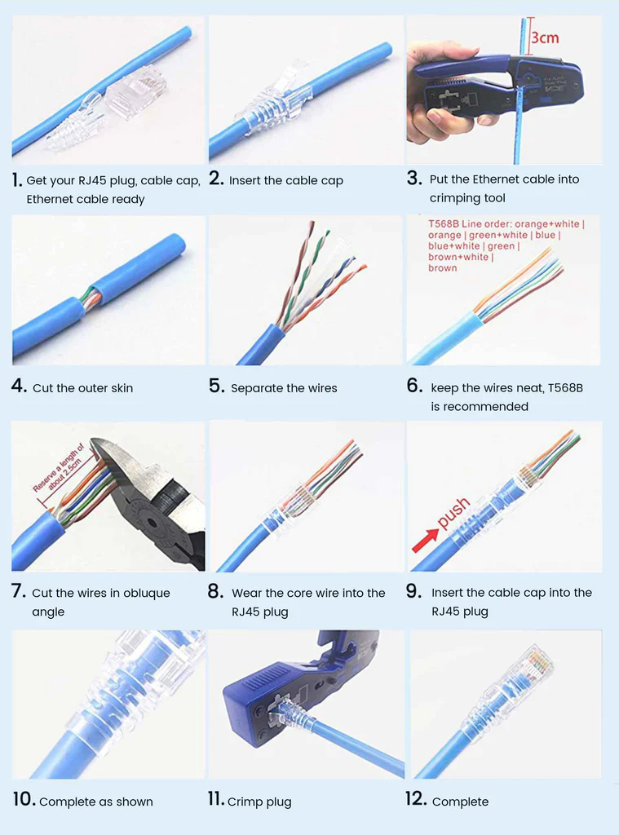

Lab 02: Transmission Media & Network Devices-Ethernet & Wireless

Introduction
This lab is about the introduction of Transmission media refers to the physical channels through which data is transmitted in a network. Ethernet, a wired transmission media, utilizes twisted pairs of fibre optic cables to transmit data at high speeds over short or long distances. On the other hand, wireless transmission media uses radio waves or infrared signals to transmit data wirelessly between devices. Network devices such as switches, routers, and access points are essential components that facilitate connectivity and data transmission within both Ethernet and wireless networks, enabling efficient communication and data transfer between networked devices.

Objectives
The objective of utilizing transmission media and network devices in Ethernet and wireless networks is to establish reliable and efficient communication infrastructure. Ethernet aims to provide high-speed and reliable wired connectivity for local area networks (LANs) and wide area networks (WANs). On the other hand, wireless networks aim to provide flexible and convenient connections for mobile devices and remote locations. The objective is to select and implement the appropriate transmission media and network devices to ensure seamless data transmission, optimal network performance, and enhanced user experience in both Ethernet and wireless environments.

Tools/Software Requirements
Packet Tracer/PuTTY

Lab Tasks
You are required to upload the lab tasks on Google Classroom/MS Teams and the name of those tasks must be in this format YourFullName_reg#.docx
Remember to comment on your code properly. Inappropriate or no comment will result in the deduction of marks.

Q.No.01: What is the Transmission Medium and describe the types of the transmission medium in detail?

A transmission medium is the physical or wireless pathway through which data is transmitted between devices. It is broadly classified into two types:
1. Guided (Wired) Media:
- Data is transmitted through physical cables.
Types:
- Twisted Pair Cable: Inexpensive, used in LANs and telephones.
- Coaxial Cable: Higher bandwidth, used for cable TV and internet.
- Fiber Optic Cable: Very high-speed transmission using light, immune to interference, used for long-distance communication.
2. Unguided (Wireless) Media:
- Data is transmitted through electromagnetic waves.
Types:
- Radio Waves: Used in Wi-Fi, cellular networks, and broadcasting.
- Microwaves: Used for satellite and long-distance communications.
- Infrared: Short-range communication, like remote controls.
- Satellite: Long-distance communication via satellites.

Q.No.02: Define the Network Devices and types of all Network Devices.

Network devices are hardware components used to connect computers and other electronic devices within a network, enabling communication and data exchange between them.
Types of Network Devices:
- Router:
  - Function: Directs data packets between networks, connects different networks, like LANs and the internet.
  - Use: Home internet, corporate networks.
- Switch:
  - Function: Connects multiple devices within a LAN and forwards data based on MAC addresses.
  - Use: Improves network efficiency in businesses.
- Hub:
  - Function: Broadcasts data to all devices in a network. It doesn't filter data.
  - Use: Basic networking, though largely outdated.
- Modem:
  - Function: Converts digital signals to analog (and vice versa) to connect computers to the internet via telephone lines.
  - Use: Home internet connections.
- Access Point (AP):
  - Function: Allows wireless devices to connect to a wired network using Wi-Fi.
  - Use: Provides Wi-Fi in homes, offices, and public areas.

Q.No.03: Difference between straight-through and crossover cable and rollover?

- Straight-Through Cable:
- Definition: A standard Ethernet cable where the wire connections (pins) on both ends follow the same pattern (TIA/EIA 568A or 568B).
- Usage: Connects different types of devices (e.g., computer to switch, switch to router).
- Pin Configuration: Both ends have the same wire sequence (e.g., T568B on both ends).
- Crossover Cable:
  - Definition: An Ethernet cable where the transmit and receive signals are crossed between the ends (one end uses T568A, and the other uses T568B).
  - Usage: Connects similar devices directly (e.g., computer to computer, switch to switch).
  - Pin Configuration: One end follows T568A, and the other follows T568B, crossing the transmit (Tx) and receive (Rx) pairs.
- Rollover Cable:
  - Definition: A cable where the pinout at one end is the exact reverse of the pinout at the other end (pin 1 connects to pin 8, pin 2 to pin 7, etc.).
  - Usage: Primarily used to connect a computer terminal to a router or switch’s console port for configuration.
  - Pin Configuration: The wires are rolled over, reversing the pinout at each end.
Key Differences:
Feature | Straight-Through Cable | Crossover Cable | Rollover Cable
Purpose | Connects different devices (e.g., PC to switch) | Connects similar devices (e.g., PC to PC) | Connects to a device's console port
Pin Configuration | Same on both ends (T568A or T568B) | Different on each end (T568A on one, T568B on the other) | Pins are reversed (1→8, 2→7, etc.)
Common Use | Data transmission in networks | Direct device-to-device connection | Device management and configuration

Q.No.04: What is Peer to Peer network explained in detail?

Peer-to-Peer (P2P) Network
A Peer-to-Peer (P2P) network is a decentralized type of network where each device (also called a "peer") can act as both a client and a server. In this model, all devices are equally privileged and can share resources directly without relying on a centralized server. Each peer in the network can initiate or complete tasks and share files, storage, or processing power with other peers.
Characteristics of Peer-to-Peer Networks:
- Decentralization:
  - There is no centralized server or authority controlling the network. Each peer communicates directly with other peers to exchange data or resources.
- Equal Roles:
  - Each peer acts as both a client and a server, meaning that all devices can request and provide services simultaneously.
- Scalability:
  - P2P networks are scalable because new peers can be added easily, without the need to modify a centralized server structure.
- Resource Sharing:
  - Peers share their resources like files, bandwidth, or processing power with other peers.
- Distributed Data:
  - Data in a P2P network is distributed across various peers, reducing the chances of a single point of failure.
Types of Peer-to-Peer Networks:
- Pure P2P Network:
  - There is no central server or hierarchy. All peers are equally responsible for initiating and maintaining the network.
- Hybrid P2P Network:
  - A combination of centralized and decentralized features. A central server is used for some tasks (like indexing or searching), but the actual data exchange occurs directly between peers

Lab 03: Introduction to Packet Tracer/PuTTY

Introduction
Packet Tracer is a network simulation and visualization tool developed by Cisco Systems. It provides a virtual environment for designing, configuring, and troubleshooting network setups. Packet Tracer allows users to create network topologies, simulate network devices, and test network functionality, aiding in the learning and practice of networking concepts.
PuTTY, on the other hand, is a popular open-source terminal emulator and SSH client for Windows. It enables secure remote access to network devices, servers, and systems using various protocols like SSH, Telnet, and Serial. PuTTY offers a user-friendly interface and powerful features for managing remote connections, executing commands, and transferring files.
Packet Tracer and PuTTY are valuable tools in networking and system administration, supporting network design, configuration, and remote access tasks.

Objectives
The objective of using Packet Tracer is to gain hands-on experience and practical knowledge in networking concepts. It allows users to design, configure, and troubleshoot virtual networks, helping them understand network behaviour and prepare for real-world scenarios.
PuTTY aims to provide a secure and reliable means of remote access and management of network devices and systems. It enables users to establish secure connections, execute commands, and transfer files remotely, enhancing efficiency and productivity in network administration tasks.
In summary, the objectives of both Packet Tracer and PuTTY are to enhance learning, practice network skills, simulate network environments, and facilitate secure remote access and management of network devices and systems.

Tools/Software Requirements
Packet Tracer/PuTTY

Lab Tasks
You are required to upload the lab tasks on Google Classroom/MS Teams and the name of those tasks must be in this format YourFullName_reg#.docx
Remember to comment on your code properly. Inappropriate or no comment will result in the deduction of marks.

Q.No.01: What is a Packet Tracer and why we are using the Packet Tracer?

Packet racer is software used to design networks between network devices and end user devices .We are using packet racer for designing networks in our Lab.

Q.No.02: Design a simple network using a switch and 4 minimum end-user devices. Assign IP addresses to each device and check if the ping is successful.

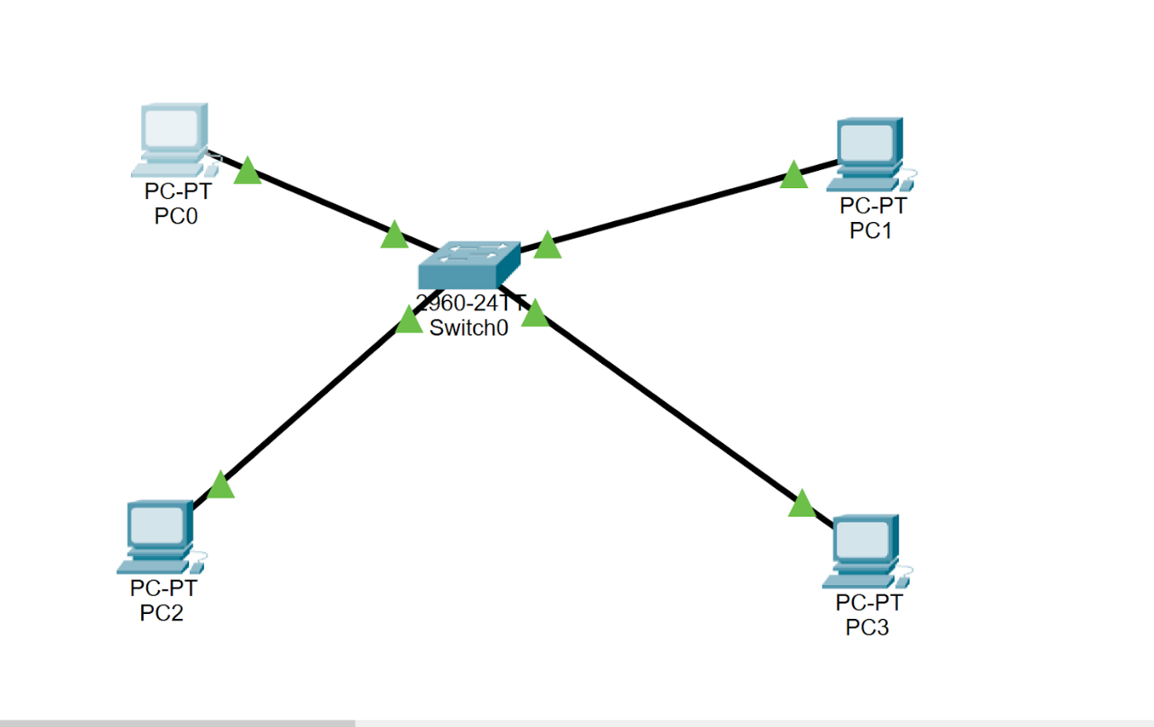



Q.No.03: Design a simple network using a switch and 4 minimum end-user devices in cisco packet tracer. Assign IP addresses to each device and check if the ping is successful.

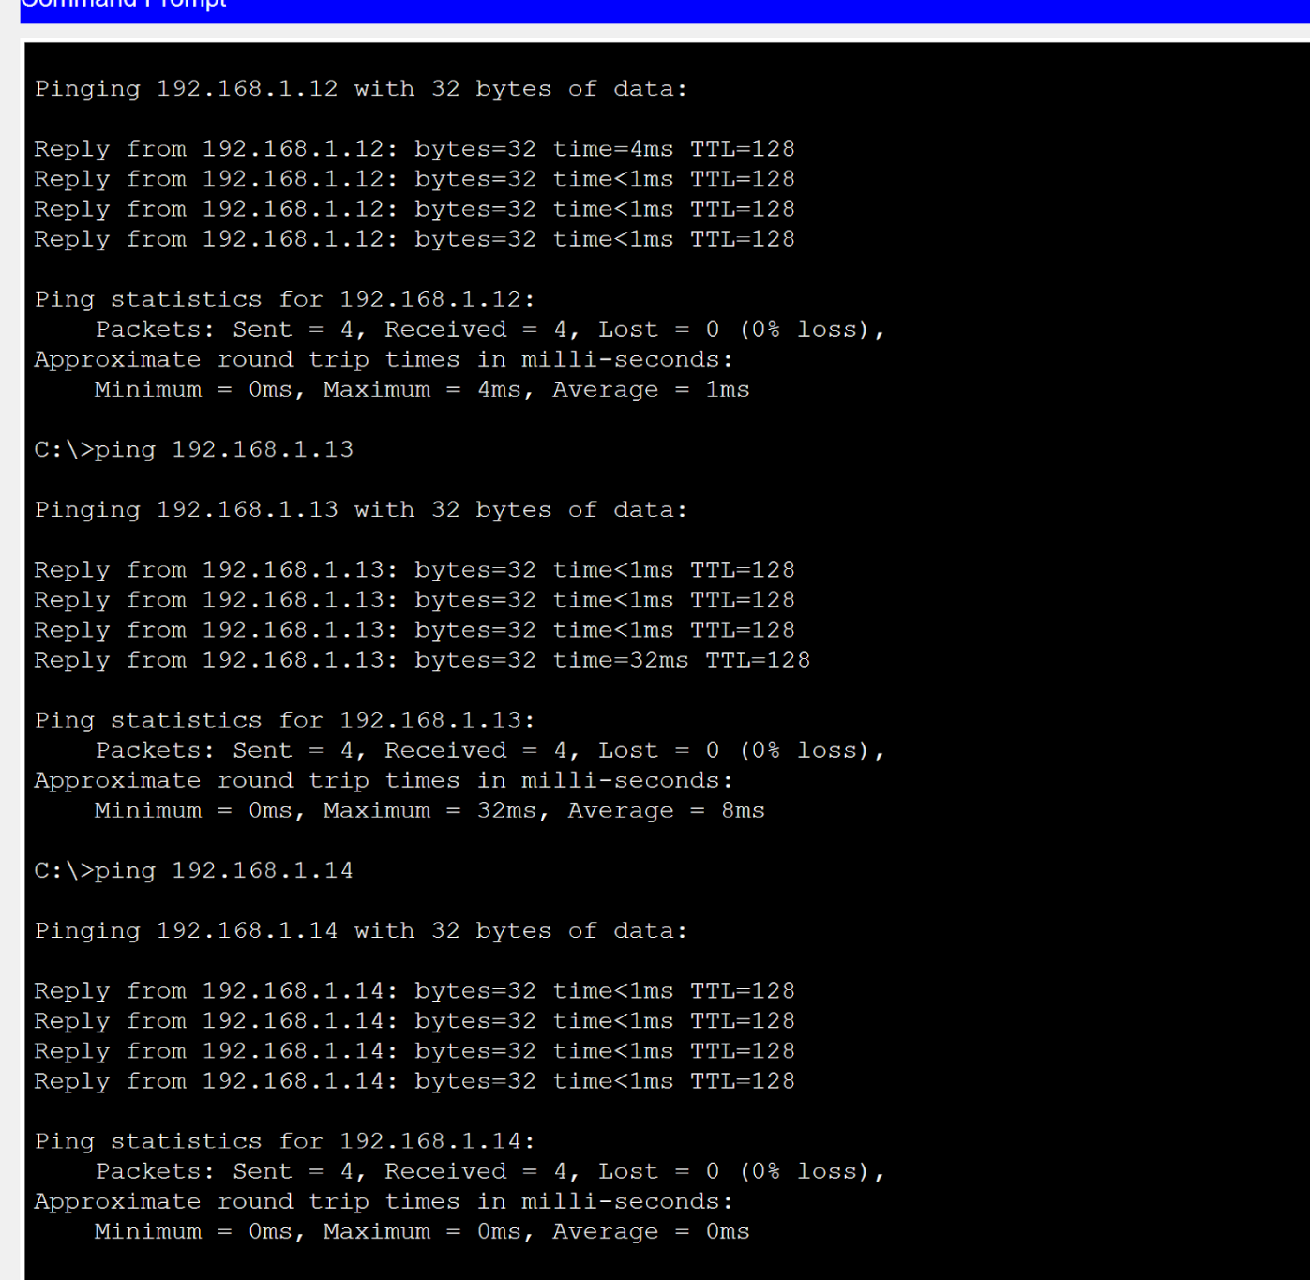


Q.No.04: Make a design of the Network by using
4x Switches
20x End-User Device

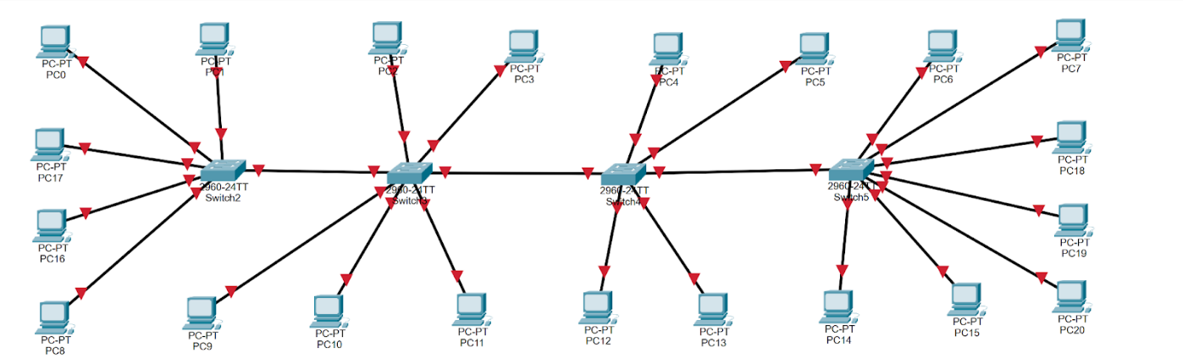
Lab 04: Classes of IP Addresses and Topology
Introduction
This lab is about the introduction of Networks an IP (Internet Protocol) address is a numerical label assigned to the devices connected to a computer network that uses the IP for communication. IP address acts as an identifier for a specific machine on a particular network. It also helps you to develop a virtual connection between a destination and a source. The IP address is also called an IP number or internet address. It helps you to specify the technical format of the addressing and packet scheme. Most networks combine TCP with IP.
Objectives
This lab will review the TCP/IP defines five classes of IP addresses: class A, B, C, D, and E. Each class has a range of valid IP addresses. The value of the first octet determines the class. IP addresses from the first three classes (A, B, and C) can be used for host addresses. The other two classes are used for other purposes – class D for multicast and class E for future experimental purposes.
Class | Private IP Address Range | Number of Addresses | Common Usage
Class A | 10.0.0.0 to 10.255.255.255 | ~16.7 million addresses | Large organizations, enterprises
Class B | 172.16.0.0 to 172.31.255.255 | ~1 million addresses | Medium-sized networks
Class C | 192.168.0.0 to 192.168.255.255 | ~65,536 addresses | Home networks, small businesses

Class | Range | Supports
Class A | 1.0.0.1 to 126.255.255.254 | Supports 16 million hosts on each of 127 networks.
Class B | 128.1.0.1 to 191.255.255.254 | Supports 65,000 hosts on each of 16,000 networks.
Class C | 192.0.1.1 to 223.255.254.254 | Supports 254 hosts on each of 2 million networks.
Class D | 224.0.0.0 to 239.255.255.255 | Reserved for multicast groups.
Class E | 240.0.0.0 to 254.255.255.254 | Reserved.

Tools/Software Requirements
Packet Tracer/PuTTY

Lab Tasks
You are required to upload the lab tasks on Google Classroom/MS Teams and the name of that tasks must be in this format YourFullName_reg#.docx
Remember to comment on your code properly. Inappropriate or no comment will result in the deduction of marks.
Q.No.02: Differentiate between IP and IP Address with an Example.

IP (Internet Protocol): is about the set of rules that guide the sending and receiving of data packets over a network.
EXAMPLE
An example of IP functioning is the delivery of an email from one user to another.
IP Address: is a unique identifier assigned to each device on a network, necessary for data delivery under the rules set by the Internet Protocol.
EXAMPLE
An example of an IP address could be 192.168.1.1 (an IPv4 address)

Q.No.03: Difference between public and private IP Addresses with ranges?

Public IP Addresses are globally unique and are necessary for devices that need direct access to the internet.
Example
IPv4: Any address not falling within the reserved private ranges.
Private IP Addresses are used within private networks and are not globally unique. They cannot directly access the internet without going through a device that provides NAT.
Example
IPv4:
- 10.0.0.0 - 10.255.255.255 (10.0.0.0/8)
- 172.16.0.0 - 172.31.255.255 (172.16.0.0/12)
- 192.168.0.0 - 192.168.255.255 (192.168.0.0/16)

Q.No.03: What is network topology explain with an (example and diagram).Paste screenshots with configurations.

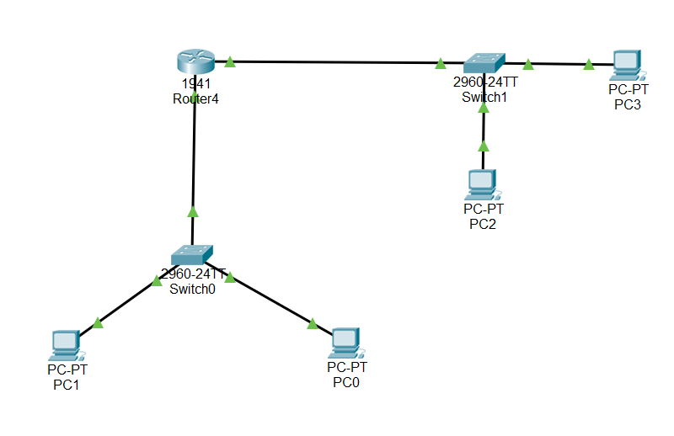

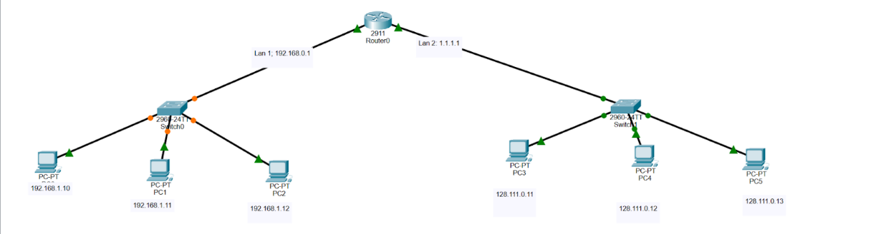
THIS IS A STAR TOPOLOGY
Lab 05: Subnetting in computer networks

Introduction
This lab is about Subnetting involves dividing the network into smaller portions called subnets. In a sense, the IP address then has three components - the network part, the subnet part, and finally the host part. All a subnet mask does is indicate how many bits are being "borrowed" from the host component of an IP address.

Objectives
This lab will review the A Class A, B, or C TCP/IP network that can be further divided, or subnetted, by a system administrator. It becomes necessary as you reconcile the logical address scheme of the Internet (the abstract world of IP addresses and subnets) with the physical networks in use by the real world.

Tools/Software Requirements
Packet Tracer/PuTTY

Lab Tasks
You are required to upload the lab tasks on Google Classroom/MS Teams and the name of those tasks must be in this format YourFullName_reg#.docx
Remember to comment on your code properly. Inappropriate or no comment will result in the deduction of marks.

Q.No.01: What is Subnetting and why do you use subnetting in Computer Networks?

Subnetting is the practice of dividing a large network into smaller, more manageable segments called subnets. It helps organize and optimize how IP addresses are assigned and used within a network.
Why Use Subnetting?
- Better IP Address Management: It helps in efficiently using IP addresses, especially when there are a limited number of them available.
- Improved Network Performance: Smaller subnets reduce network traffic and make communication more efficient.
- Enhanced Security: By isolating different parts of the network, you can better control access and protect sensitive data.
- Easier Troubleshooting: Smaller subnets make it easier to identify and resolve network issues.
- Scalability: Subnetting allows networks to grow without needing a new IP range.

Q.No.02: Break 201.1.1.0 networks into 40 hosts each.

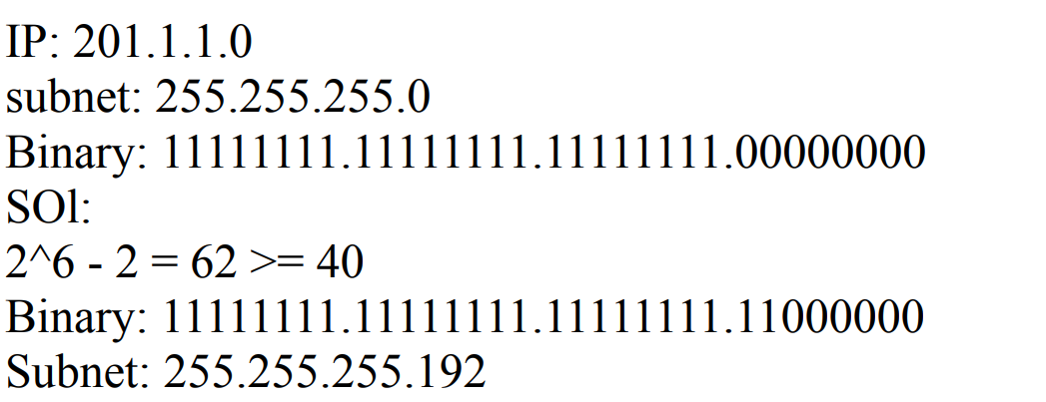

Q.No.03: Break 175.15.0.0 networks into 1000 hosts each

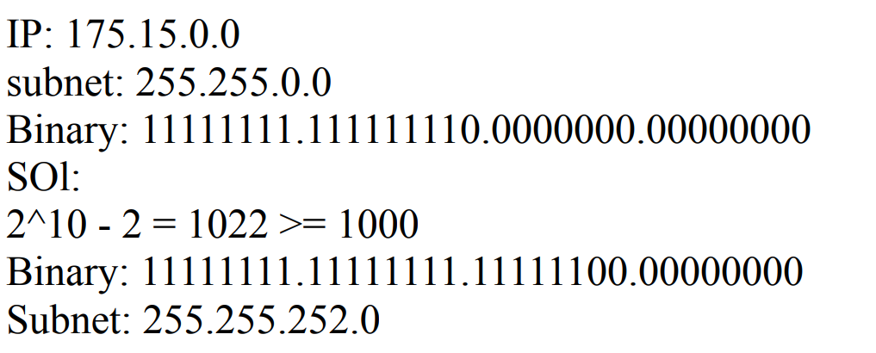

Q.No.04: Break 15.0.0.0 into networks of 100 hosts each.

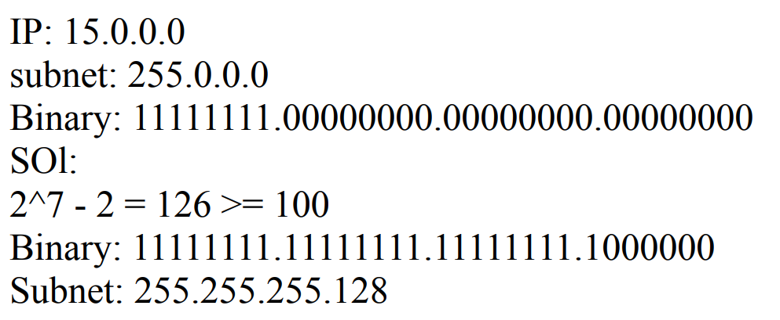
Lab 06: IP Routing

Introduction
This lab is about IP routing, the process that defines the best or shortest path through which data travels to reach from source to destination. It determines the shortest path to send the data from one computer to another computer in the same or different network. Routing uses different protocols for the different networks to find the path that data follows. It defines the path through which data travels across multiple networks from one computer to another. Forwarding the packets from source to destination via different routers is called routing. The routing decision is taken by the routers.
Objectives
This lab will the objective of IP routing is to enable efficient and reliable packet delivery across interconnected networks. It aims to determine the best path for data transmission based on factors like network congestion, link availability, and routing metrics. IP routing ensures optimal utilization of network resources, minimizes packet loss and reduces network latency. Additionally, it allows for scalability, flexibility, and fault tolerance in network infrastructures, enabling seamless communication and connectivity between diverse network segments and devices.

Tools/Software Requirements
Packet Tracer/PuTTY

Lab Tasks
You are required to upload the lab tasks on Google Classroom/MS Teams and the name of that tasks must be in this format YourFullName_reg#.docx
Remember to comment on your code properly. Inappropriate or no comment will result in the deduction of marks.

Q.No.01: What is IP Routing in detail?

IP routing is the process of moving data packets from one network to another using the Internet Protocol (IP). It is a fundamental aspect of computer networking and is responsible for delivering data packets to their intended destination on the network.

1. Routing Table: At the heart of IP routing is the routing table, which is a database maintained by each network device, such as a router or a switch. The routing table contains information about the available networks and the best paths to reach them.

2. Network Interfaces: Each network device has one or more network interfaces, which are the physical or logical connections to the network. The routing table maps network destinations to these interfaces.

3. Routing Protocols: Routing protocols are used to dynamically update the routing tables on network devices. Examples of common routing protocols include RIP, OSPF, EIGRP, and BGP. These protocols allow devices to exchange routing information and learn about the best paths to reach different networks.

4. Packet Forwarding: When a device receives an IP packet, it looks up the destination IP address in its routing table. Based on the information in the table, the device determines the appropriate interface to forward the packet through, and then sends the packet to the next hop along the path.

5. Routing Algorithms: IP routing relies on various algorithms to determine the best paths to reach destinations. These algorithms consider factors such as network topology, link costs, and traffic load to select the most efficient routes.

6. Unicast, Multicast, and Broadcast Routing: IP routing supports different types of packet delivery:
- Unicast: Packets are sent from a single source to a single destination.
- Multicast: Packets are sent from a single source to multiple destinations.
- Broadcast: Packets are sent from a single source to all devices on the same network.

7. Routing Domains and Autonomous Systems: Large networks are often divided into routing domains, also known as autonomous systems (AS). Each AS has its own set of routing policies and protocols, and they exchange routing information at the borders using protocols like BGP.

8. Routing Security: Securing IP routing is crucial, as routing misconfigurations or attacks can disrupt network connectivity and enable various security threats. Techniques like route filtering, authentication, and encryption are used to enhance the security of IP routing.

IP routing is a fundamental component of modern computer networks and is essential for the seamless communication and data exchange between devices across the internet and local networks.

Q.No.02: Perform the Static and dynamic routing protocol.
(Using 5 routers, 5 switches, and 15 PCs, 3x PCs of each switch)

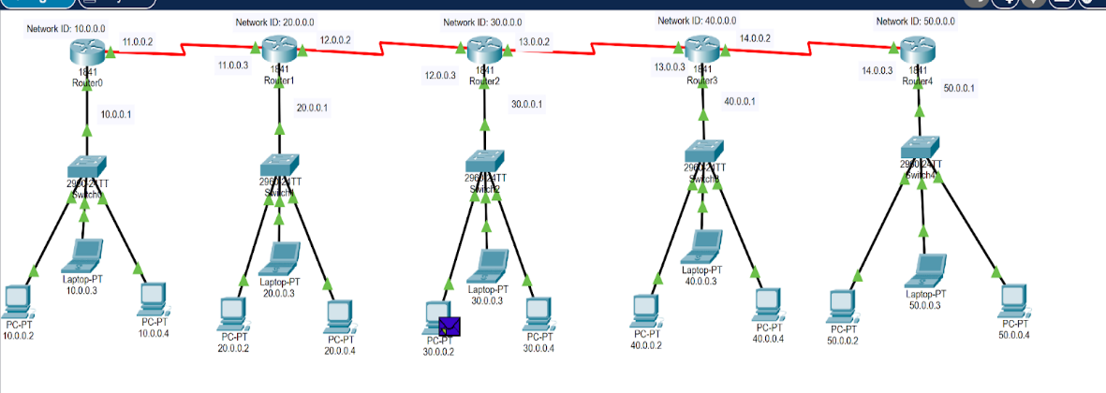STATIC
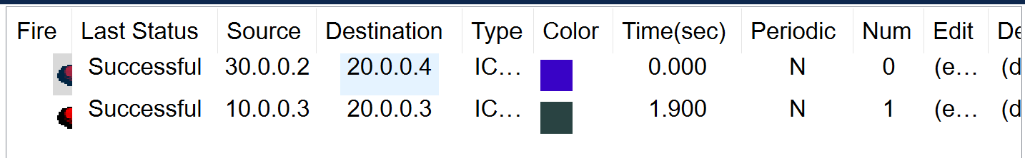

DYNAMIC:

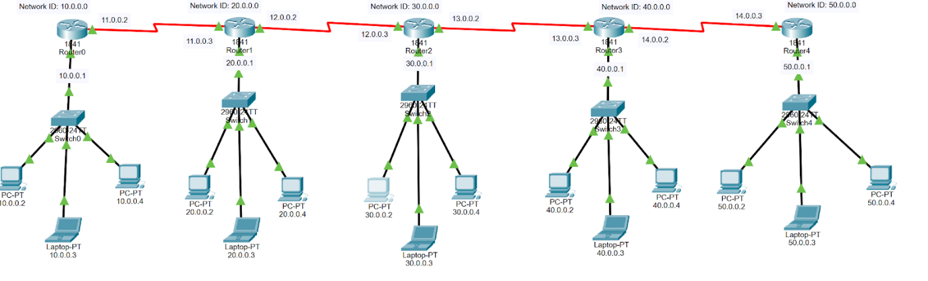
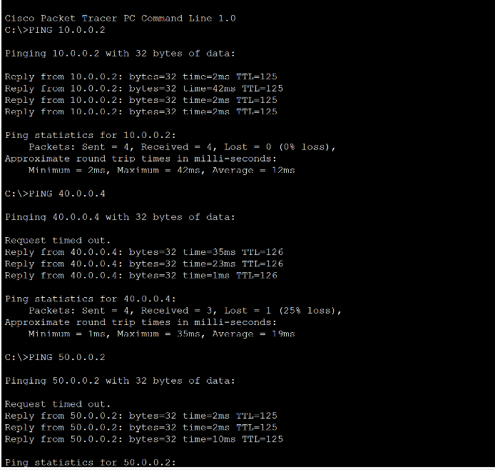

Q.No.03: What is the Protocol write-down of all useable routing protocols?

RIP (Routing Information Protocol) is an Interior Gateway Protocol (IGP) that uses hop count as the routing metric. It is a distance-vector routing protocol, with the most common versions being RIPv1 and RIPv2.

OSPF (Open Shortest Path First) is another IGP that uses the Dijkstra algorithm to determine the shortest path. It is a link-state routing protocol that divides networks into areas for better scalability.

EIGRP (Enhanced Interior Gateway Routing Protocol) is a hybrid routing protocol developed by Cisco. It combines features of distance-vector and link-state protocols, using the DUAL algorithm for route calculation. EIGRP is also an IGP.

IS-IS (Intermediate System to Intermediate System) is a link-state routing protocol similar to OSPF, commonly used in large service provider networks. It is also an IGP.

BGP (Border Gateway Protocol) is the de facto standard for routing between autonomous systems (AS) on the internet. It is an Exterior Gateway Protocol (EGP) that uses path vector routing and relies on policies for route selection.

IGRP (Interior Gateway Routing Protocol) is an older Cisco-proprietary distance-vector routing protocol that has been superseded by EIGRP.

Static Routing involves the manual configuration of routes on network devices, without the use of a dynamic routing protocol.

The choice of routing protocol depends on factors such as network size, complexity, performance requirements, and administrative policies. Larger networks often use a combination of IGP and EGP protocols to efficiently manage routing within and between autonomous systems.

Q.No.04: Difference between the RIP V1 and RIP V2 and implementation of RIP V1 & V2.
(Using 3 routers, 3 switches, and 9 PCs, 3x PCs of each switch)

The main differences between RIP version 1 (RIPv1) and RIP version 2 (RIPv2) are:
- Subnet Mask Support:
  - RIPv1 does not support variable-length subnet masks (VLSM). It assumes that all subnets have the same subnet mask.
  - RIPv2 supports VLSM, allowing for more efficient use of IP address space.
- Authentication:
  - RIPv1 does not support authentication, making it vulnerable to unauthorized access and routing updates.
  - RIPv2 supports simple password authentication and MD5 authentication, improving the security of routing updates.
- Classless Routing:
  - RIPv1 is a classful routing protocol, which means it does not include subnet mask information in its routing updates.
  - RIPv2 is a classless routing protocol, which means it includes the subnet mask information in its routing updates, enabling it to support VLSM.
- Routing Table Updates:
  - RIPv1 uses broadcast addresses (255.255.255.255) to send updates, which can cause unnecessary load on network devices that are not part of the same subnet.
  - RIPv2 uses multicast addresses (224.0.0.9) to send updates, reducing the impact on non-participating devices.
- Next Hop Information:
  - RIPv1 does not include next-hop information in its routing updates, which can lead to suboptimal routing decisions in certain network topologies.
  - RIPv2 includes next-hop information in its routing updates, which can improve the routing performance.
- Convergence Time:
  - RIPv1 has a slower convergence time compared to RIPv2 due to the lack of support for VLSM and next-hop information.

Lab 07: OSPF Configuration

Introduction
This lab is about OSPF, OSPF (Open Shortest Path First) is a widely used routing protocol in computer networks, designed to find the best path for data packets between routers. It is a link-state routing protocol and part of the Interior Gateway Protocol (IGP) family, primarily used within an organization's network (intranet).

Objectives
The objective of an OSPF configuration lab is to provide practical experience and understanding of configuring, verifying, and troubleshooting OSPF in a simulated or real-world networking environment.

Tools/Software Requirements
Packet Tracer/PuTTY

Lab Tasks
You are required to upload the lab tasks on Google Classroom/MS Teams and the name of those tasks must be in this format YourFullName_reg#.docx
Remember to comment on your code properly. Inappropriate or no comment will result in the deduction of marks.

Q.No.01: What is a wildcard mask? Why it used in networking specially in OSPF?

A wildcard mask is a concept used in networking, particularly in OSPF (Open Shortest Path First) routing protocol. It is a type of network mask that is used to specify which bits in an IP address should be matched during a routing or access control list (ACL) operation.
The wildcard mask is the inverse of a subnet mask. While a subnet mask is used to identify the network portion of an IP address, a wildcard mask is used to identify the host portion of an IP address.
The wildcard mask is represented by a series of ones and zeros, where a zero indicates that the corresponding bit in the IP address must be matched, and a one indicates that the corresponding bit can be ignored or "wildcarded."
For example, if you have a wildcard mask of 0.0.0.255, it means that the first 24 bits (3 octets) of the IP address must be matched, but the last 8 bits (1 octet) can be any value.
In OSPF, wildcard masks are used in the following scenarios:
- OSPF Area Configuration: When configuring OSPF areas, you can use a wildcard mask to specify which networks should be included in the area. This allows for more flexible and efficient area configuration, especially in large networks.
- OSPF Network Statement: When configuring OSPF network statements, you can use a wildcard mask to specify the networks that should be advertised by the OSPF routing process. This can help simplify the configuration and reduce the number of network statements required.
- OSPF Access Control Lists (ACLs): Wildcard masks are also used in OSPF ACLs, which are used to control which OSPF routing updates are accepted or rejected. The wildcard mask allows you to specify which parts of the IP address should be matched during the ACL evaluation.
The main benefit of using wildcard masks in OSPF is that they provide a more flexible and efficient way to configure and manage OSPF networks, especially in large-scale environments. By allowing you to specify the parts of the IP address that should be matched, wildcard masks can help reduce the complexity of the OSPF configuration and improve the overall performance and scalability of the routing protocol.

Q.No.02. Perform the RIP (V1, V2) protocol.

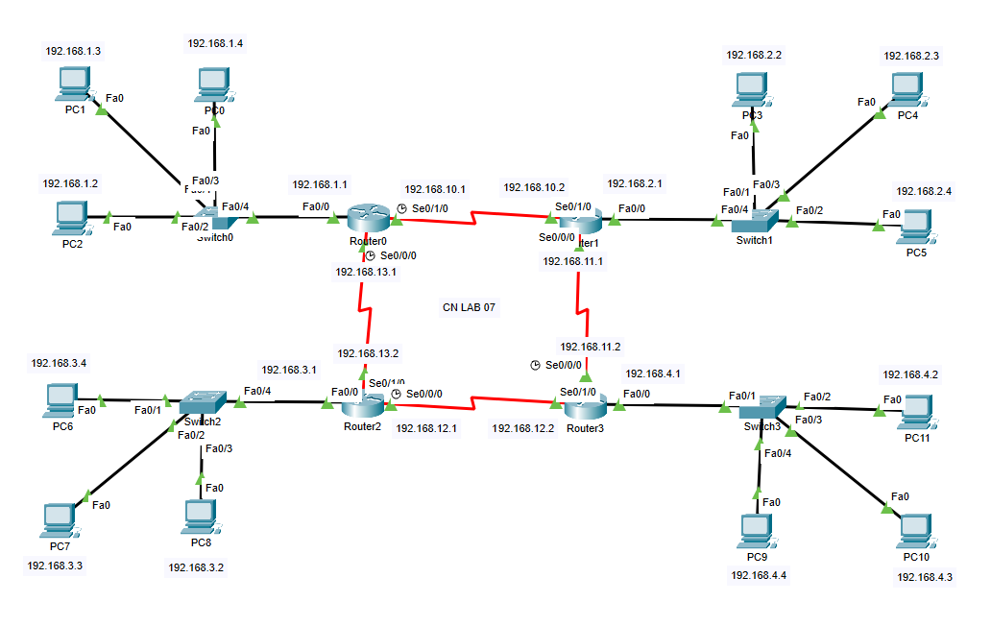

Q.No.03: Perform the OSPF protocol.
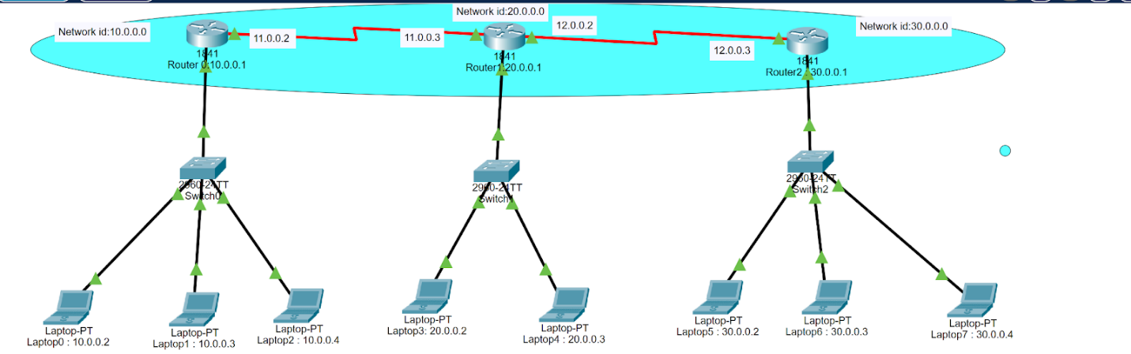
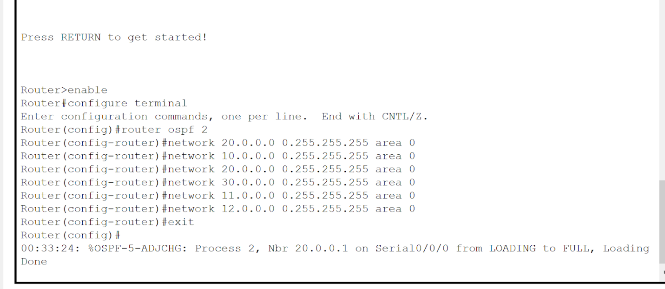

Lab 08: DHCP Configuration
Introduction
DHCP (Dynamic Host Configuration Protocol) is a network management protocol used to automatically assign IP addresses and other network configuration parameters to devices (such as computers, printers, and smartphones) on a network. It simplifies network management by reducing the need for manual configuration of devices.
DHCP Server: A server (or router) that manages and assigns IP addresses to devices on the network. It has a range of available IP addresses, called the IP address pool, and dynamically allocates them to requesting devices.
DHCP Client: Any device that connects to the network and requests an IP address from the DHCP server. Examples include computers, smartphones, and printers.
IP Address Pool: The range of IP addresses that the DHCP server can assign to clients. This pool is preconfigured in the DHCP server settings.
Objectives
The objective of the DHCP lab practical is to provide hands-on experience in configuring and managing a DHCP server to automatically assign IP addresses and network settings to client devices on a network. By setting up a DHCP server and client devices, the lab helps participants understand the process of IP address allocation, subnetting, and network communication between devices within a local area network (LAN).
Additionally, the practical aims to familiarize students with key DHCP components such as IP address pools, lease times, default gateways, and DNS configuration. Through this exercise, participants will learn how to troubleshoot DHCP-related issues, ensuring efficient network management and connectivity by automating IP address assignment, reducing the need for manual configuration
CLI commands for DHCP configuration
ip dhcp pool LAN
network 192.168.1.0 255.255.255.0
default-router 192.168.1.1
dns-server 8.8.8.8 8.8.4.4
Tools/Software Requirements
Packet Tracer/PuTTY

Lab Tasks
You are required to upload the lab tasks on Google Classroom/MS Teams and the name of that tasks must be in this format YourFullName_reg#.docx
Remember to comment on your code properly. Inappropriate or no comment will result in the deduction of marks.

Q.No.01:What are the two types of IP configuration?

The two main types of IP configuration are:
- Static IP Configuration:
  - In static IP configuration, the IP address, subnet mask, default gateway, and DNS server addresses are manually assigned to the network device.
  - The IP address and other network settings remain fixed and do not change automatically.
  - Static IP configuration is commonly used for servers, routers, and other network devices that require a consistent, predictable IP address.
- Dynamic IP Configuration (DHCP):
  - In dynamic IP configuration, the network device's IP address and other network settings are automatically assigned by a DHCP (Dynamic Host Configuration Protocol) server.
  - When the device connects to the network, it requests an IP address from the DHCP server, which then assigns an available IP address to the device.
  - The IP address assigned to the device may change over time as the DHCP server manages the IP address pool.
  - Dynamic IP configuration is commonly used for client devices, such as PCs, laptops, and mobile devices, where a constantly changing IP address is acceptable.

Q.No.02: Configure DHCP on the Cisco Packet Tracer.
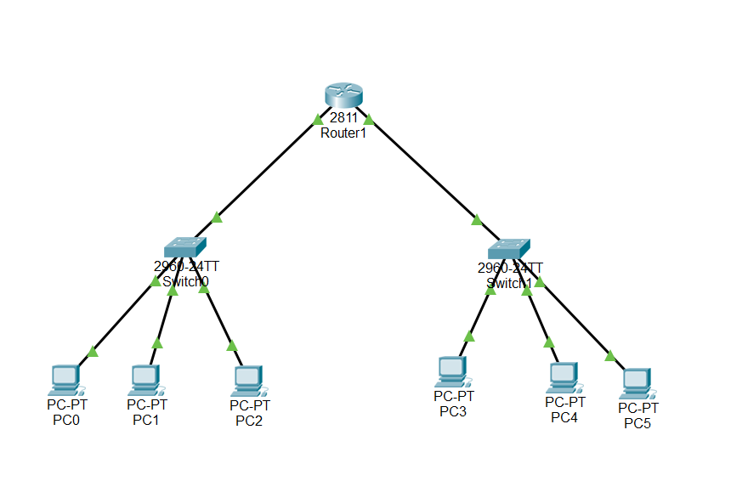

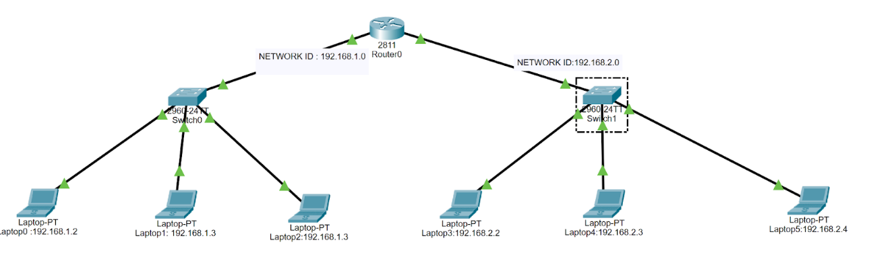

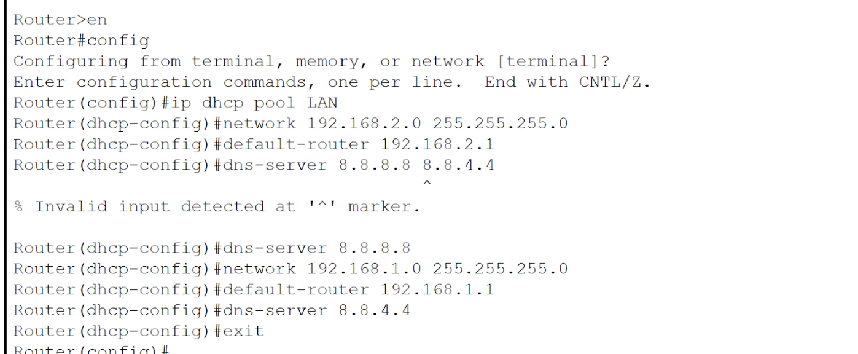

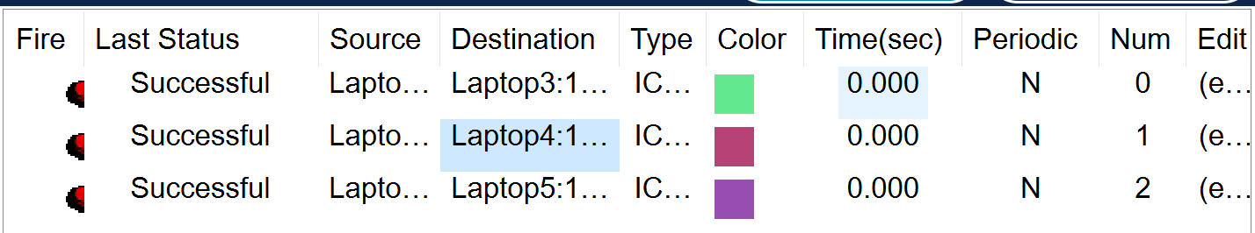

Lab 09: Network Design and Configuration -UDP and TCP

Introduction
This lab is consisting of the following Network design is a category of systems design that deals with data transport mechanisms. As with other systems' design disciplines, network design follows an analysis stage, where requirements are generated, and precedes implementation, where the system (or relevant system component) is constructed. The Configuration of the UDP and TCP.

Objectives
This lab assignment will review Communications and computer networks are essential to the success of large and small organizations alike. They link people, support operating systems, and provide companies access to the resources they need to function. Network design is growing increasingly complicated to suit the needs of companies regularly.
The backbone of a company’s operation is its IT network, which links all the computer systems and connected devices, allowing employees to operate more effectively across the board. Anything so mission-critical must be properly developed and set up. This article intends to help you learn the fundamentals of excellent network infrastructure design if you’re wondering how to build a network.

Tools/Software Requirements
Packet Tracer/PuTTY

Lab Tasks
You are required to upload the lab tasks on Google Classroom/MS Teams and the name of that tasks must be in this format YourFullName_reg#.docx
Remember to comment on your code properly. Inappropriate or no comment will result in the deduction of marks.

Q.No.01: What are the network design methodology and types of network design?

Network design isn't just about plugging in cables and setting up routers. It's a thoughtful process tailored to meet specific needs. Here’s how it generally unfolds:
- Requirement Analysis: It all starts by understanding what you need the network to do, taking into account both user needs and business objectives.
- Network Assessment: Next, take a good look at what you already have in place. This helps determine what can be reused and what needs an upgrade.
- Design Planning: Now, map out the setup. Decide on the arrangement and the tools (like hardware and software) you’ll use.
- Prototyping: Before going full scale, a small model version is built to check if the plan works in the real world.
- Implementation: This is where the full-scale setup comes to life based on the plan.
- Testing and Optimization: After setting everything up, it’s crucial to test if it performs well and make tweaks as needed.
- Documentation and Maintenance: Finally, jot down all the details for future reference and set up a routine for keeping the network healthy.
Exploring Types of Network Design
Networks come in all shapes and sizes, each designed for specific settings:
- Local Area Network (LAN): Think of this as the network in your office or school, connecting all the computers in a small area.
- Wide Area Network (WAN): This type stretches over large distances, linking together multiple smaller networks (like LANs) across cities or even countries.
- Campus Network: A bigger sibling to LANs, these networks cover multiple buildings within a single area like a university campus.
- Data Center Network: These powerhouse networks handle massive amounts of data, designed for rapid access and processing in places like server farms.
- Cloud Network: Floating up in the cloud, these networks are all about virtual resources and services, accessible anywhere, anytime.
- Enterprise Network: Large businesses rely on these, combining the power of LANs and WANs to support complex operations.
- Wireless Network: Free from the ties of cables, these networks use Wi-Fi or other technologies to keep devices connected on the go.

Q.No.02: Configure the UDP and TCP Protocol on the Cisco Packet Tracer.

